How deploy the UI5 applications into HANA Studio

**Bule Mark:** If did any changes in application we can findout using symbol (>)heileghted by blue color. If the symbol is avliable on application that application had changed and waiting for deploy.

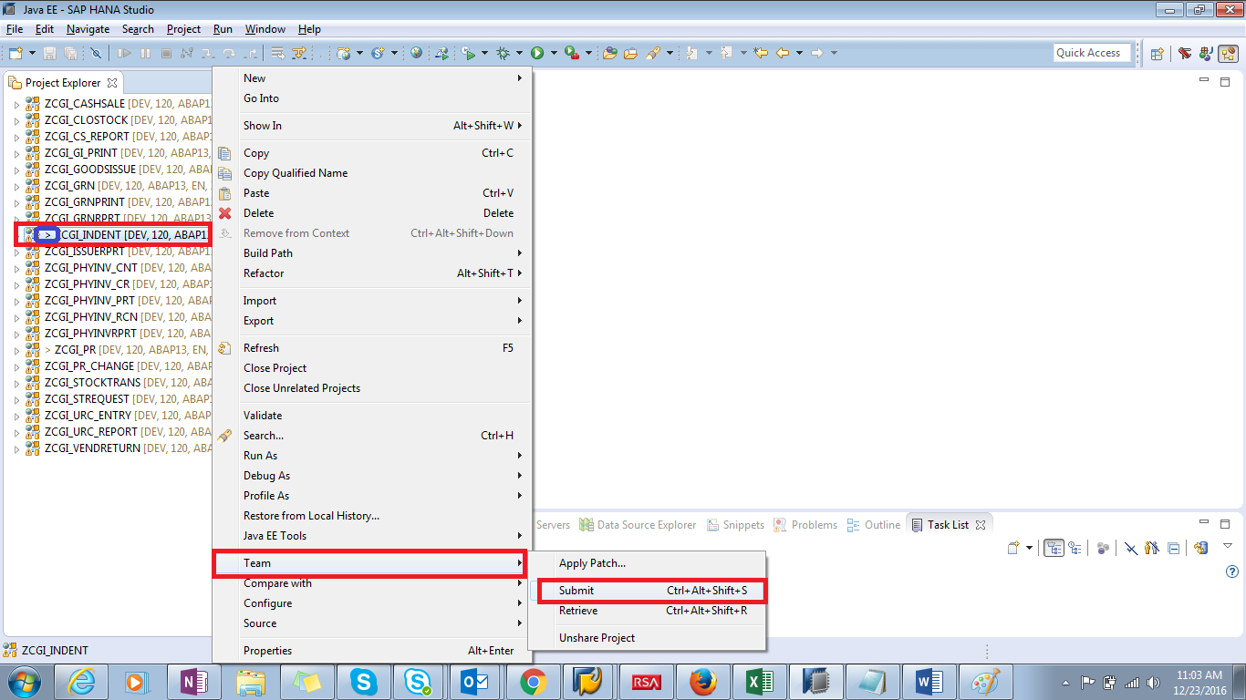

If application is not deployed into ECC System “Submit” will be enable mode under “Team”

If application is deployed into ECC System “Submit” will be disabled mode under “Team”. So that we can’t the application. If you want to deploy the same application you can change any code and deploy that time “Submit” will be enable mode under “Team”.

Click on “Submit”

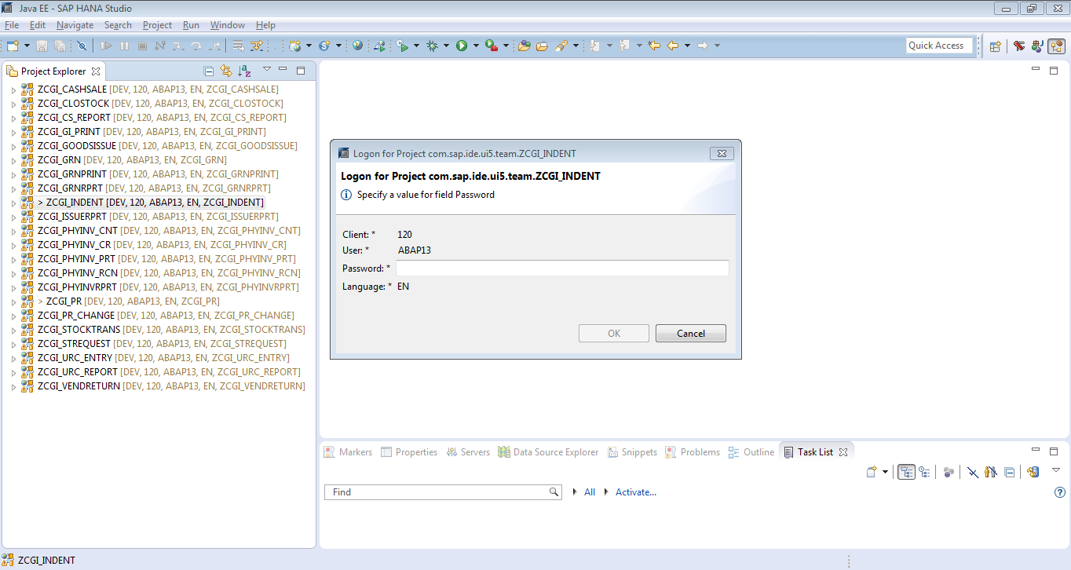

Here we will give the “password” and click “OK”

How to import applications into HANA Studio from ECC System

1. Create UI5 application into HANA without creating View.

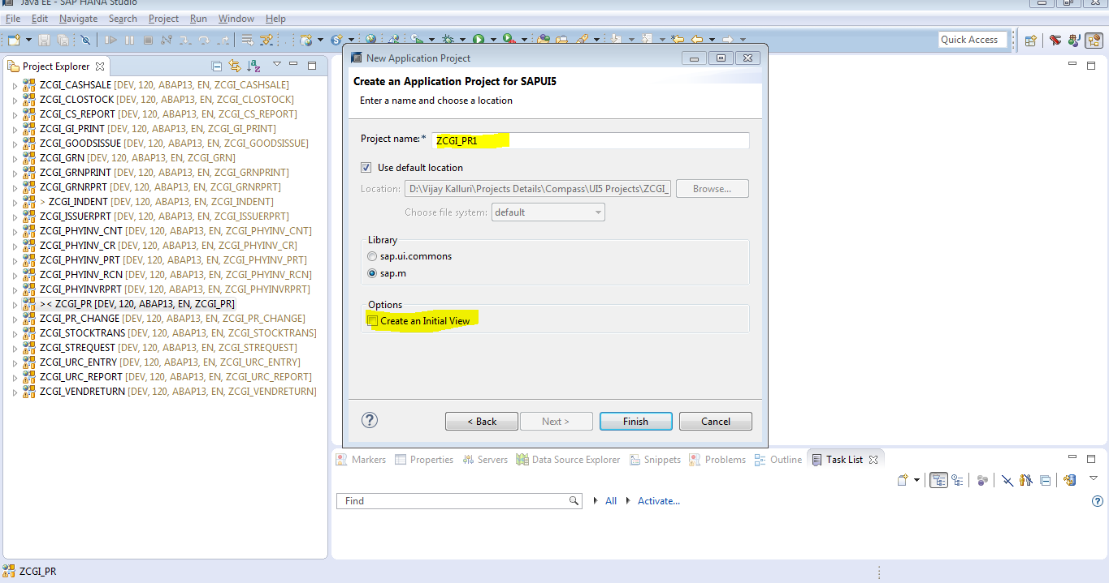

Then Right Click on Project---- Go to “Team”

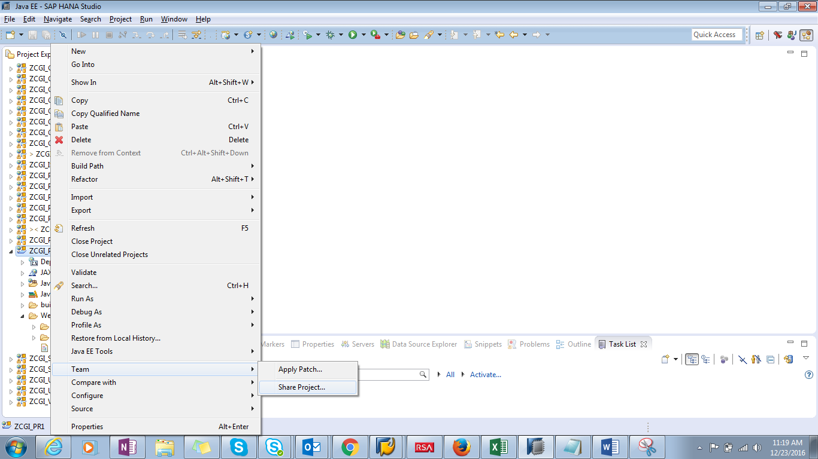

Click on “Shared Project”

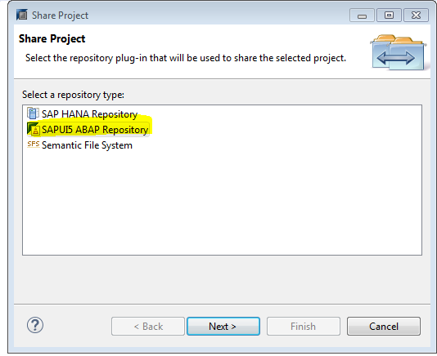

Select “SAPUI5 ABAP Repository” and click on Next. Because all UI5 application into the ECC System.

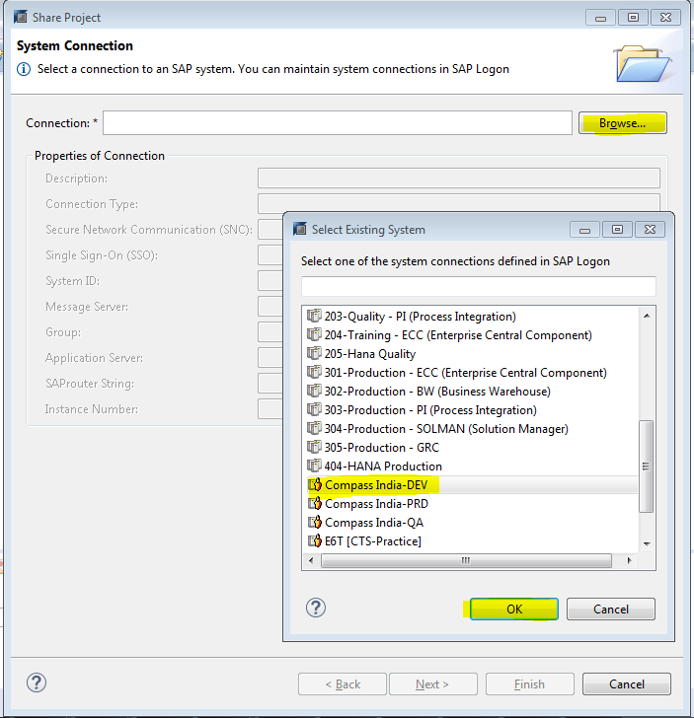

Click on “OK”

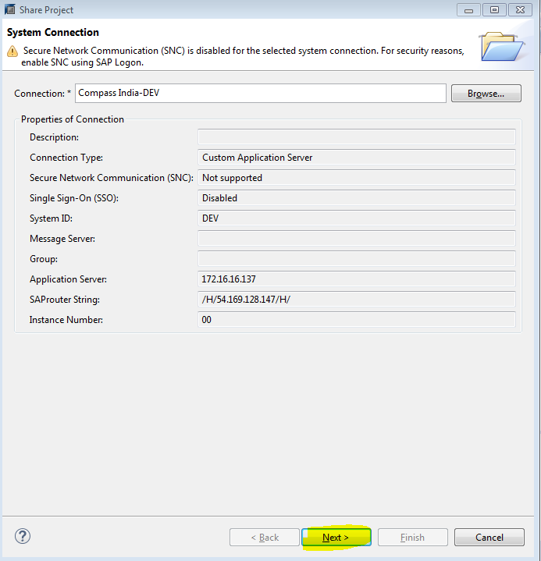

Click on “Next”

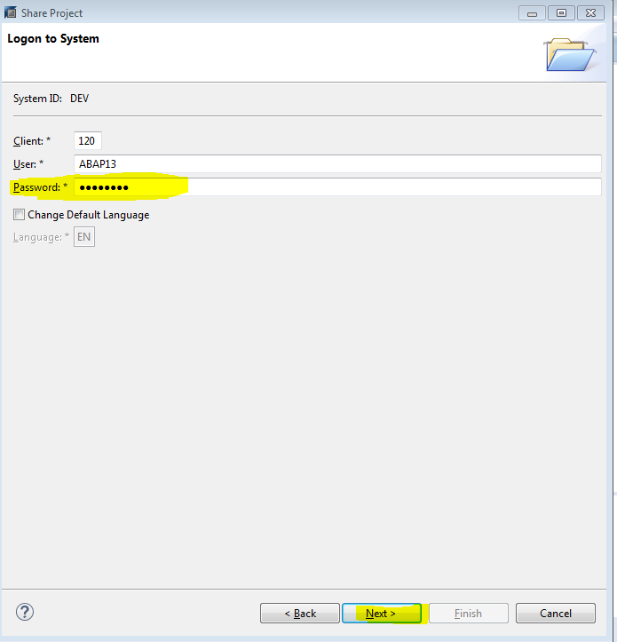

Click on “Next”

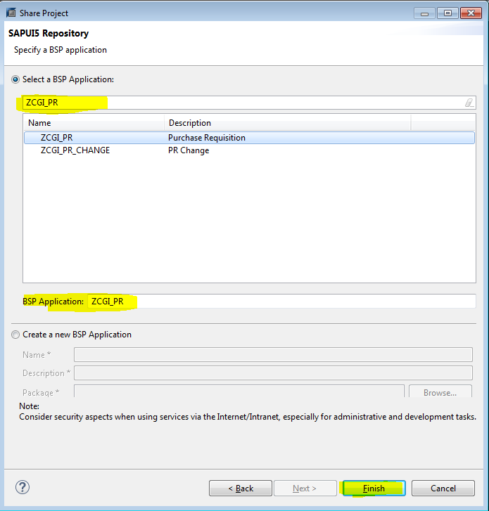

Search the Project Name (ZCGI_PR) and select the Project and Click on “Finish”. Project will be created.

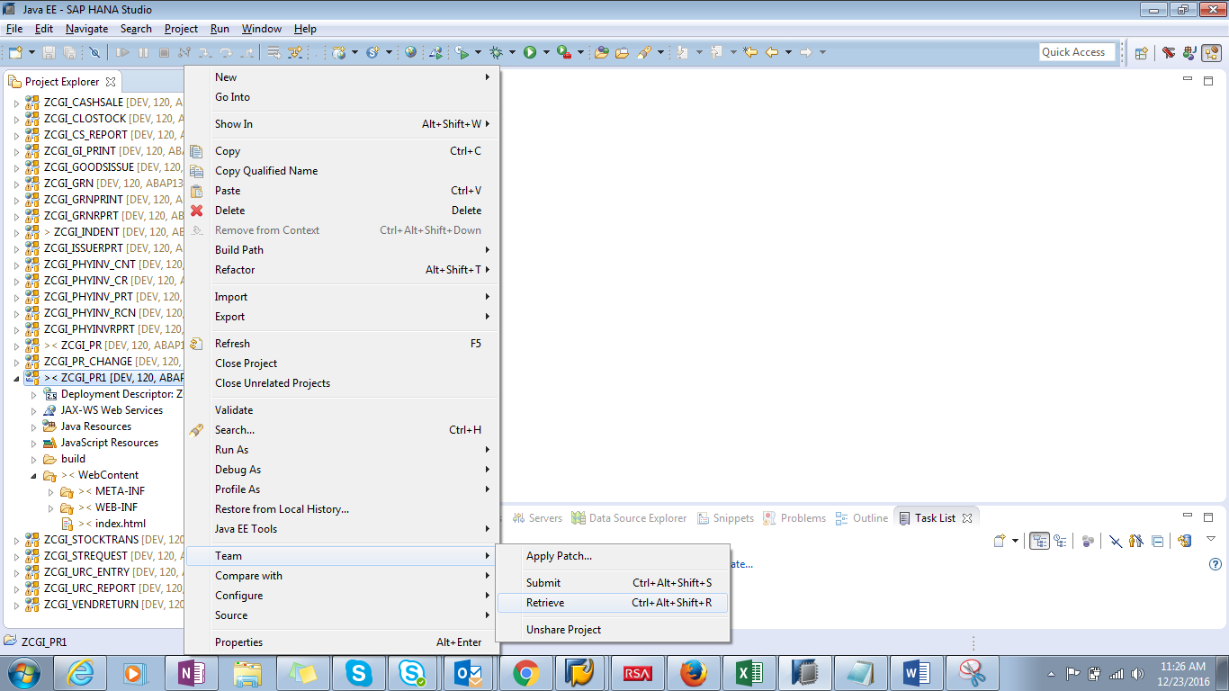

Then Right click on “Project”---- Team ------Click on “Retrieve”

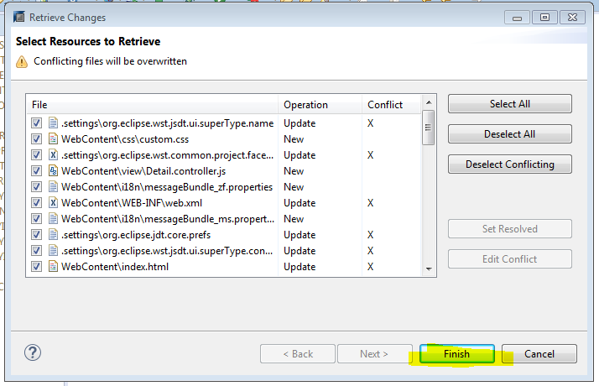

Click on “Finish”. Project will be created with all

